Replayer User Manual
Version 0.3.0 (Beta 2)

Overview
Replayer is a free media player for use during rehearsals with playback music. It's main feature is fast navigation to predefined cues in the playback media.
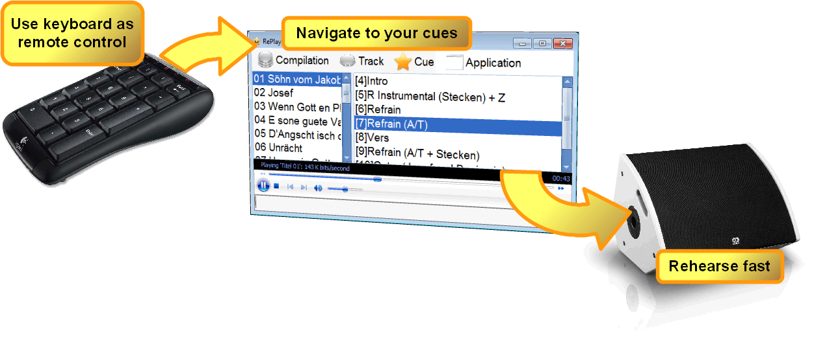Illustration 1: How to use replayer

Notions
- A cue is a named moment in time in a track.
- A track consists of a media file and any amount of cues for that.
- A compilation is an ordered set of tracks.

Download
Get your copy directly from the project page at http://replayer.codeplex.com.
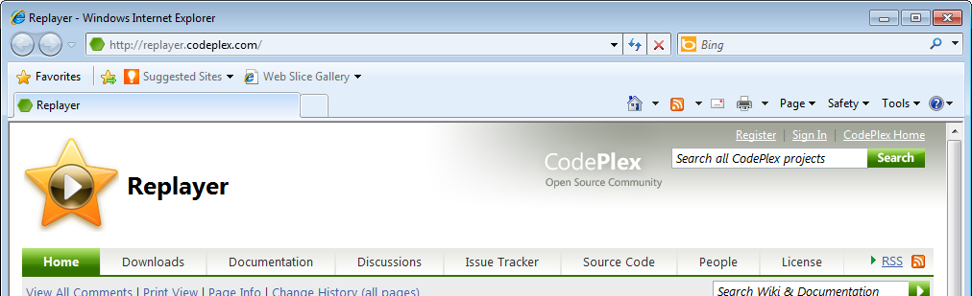Illustration 2: Replayer project page at codeplex.com
It is available for Windows XP, Vista and Windows 7, as a Click-Once-Installer.
Replayer is provided by www.codeministry.ch for free (LGPL-licensed). It's open-source.

Requirements
- Microsoft .NET Framework 3.5 Full Profile. The will automatically get installed with the application installer, if needed.
- Windows Media Player. This is included in Windows per default.

Installation
After download from the project page, the installer starts automatically, downloading and installing all prerequisites if needed. You can accept all the default values.
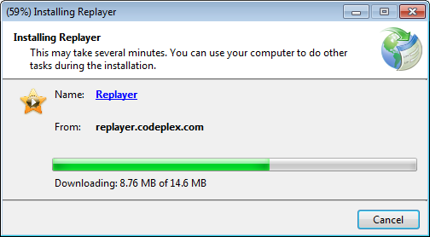Illustration 3: Installation of Replayer

Getting started...
For your first use of Replayer, create your own compilation using the wizard via “Compilation/Create new...” in the menu. Currently, no ready-made public compilations are available.
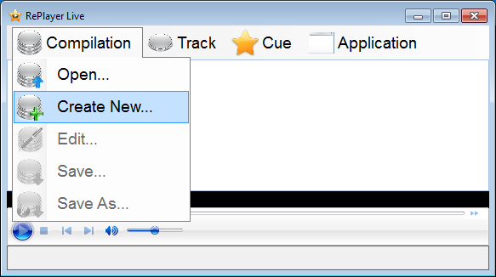Illustration 4: Creating a new compilation from the menu

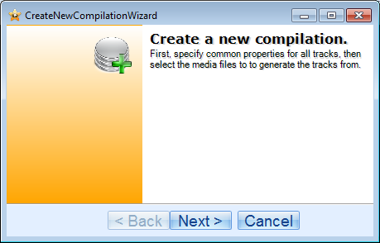Illustration 5: The wizard for creating a new compilation
On the next page, define all values for the new compilation and it's tracks as needed. You can also edit all properties later on or leave the fields empty if you wish.
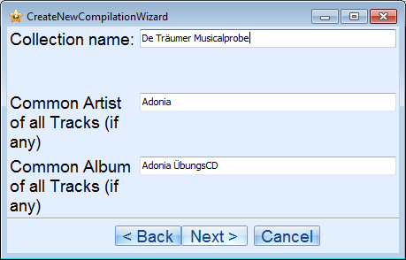Illustration 6: Common values for the compilation
On the next page, you can browse for and add media files. Each file will generate a new track with a single cue at the start position. You will later on add cues and change the descriptions as needed.
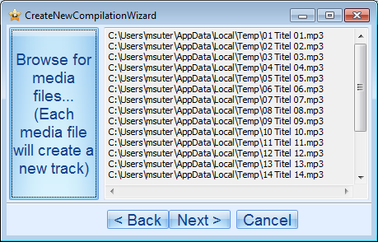Illustration 7: Adding media files
Done!
Alternatively, as a conductor for Adonia, you may have already access to an existing compilation from Marcel Wittwer.

Loading an existing compilation
Choose Compilation/Open and select a compilation via the file browser. The last loaded compilation is automatically loaded again at the next application startup.
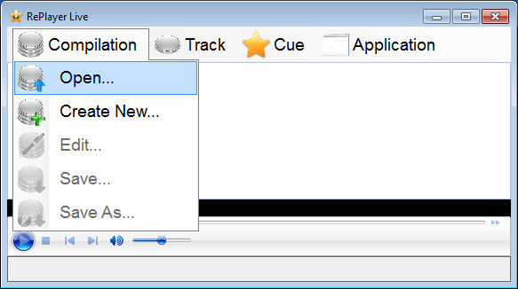Illustration 8: Opening an existing compilation

Navigation
To navigate to a specific cue point, you have 2 options:

Using the mouse
- In the list of tracks, select the one you like to rehearse.
- In the presented list of available cues, select the desired cues by a click..
- By hitting the ENTER key or by double-click, playing starts at this cue.

Using the keyboard
- By directly entering the shortcut key combination (shown in is square brackets) terminated by ENTER, you can navigate directly to the desired cue.
- By hitting the ENTER key again, playback will start.
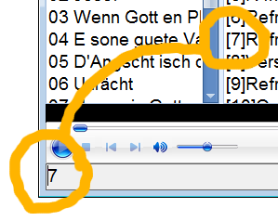Illustration 9: Using the shortcut to navigate to a cue

Keyboard Shortcuts
All frequently used actions are available via specific shortcut keys. For convenience, most of them are all available from the numeric keypad.
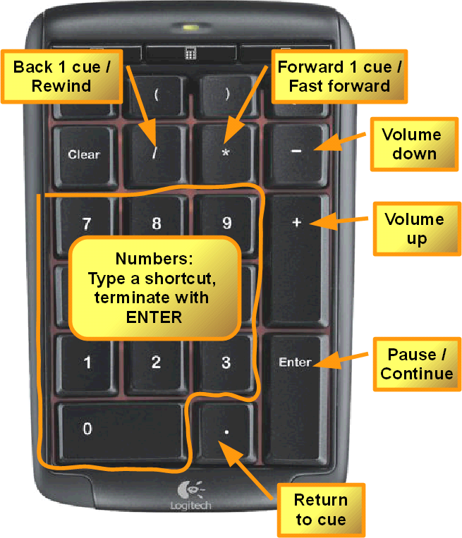Illustration 10: Shortcuts on a numeric keypad

Editing items

To modify the properties of the compilation itself, use Compilation/Edit. To modify a track or a cue, right-click on the item in question and select Edit from the context menu.
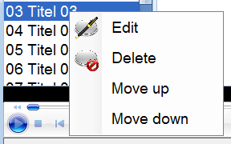Illustration 11: Editing a track

Compilation types

XML compilations (*.rex)
This type of compilation contains a list of tracks with their cue points. Each track refers to an external media file on the local file system. The content of the media file is not part of the compilation.

ZIP compilation (*.rez)
This type is a ZIP archive (as a single file), containing an XML compilation plus the complete set of referenced media files. This allows distributing ready-to-use compilations as a single file.

Compatibility
The current version allows the opening of compilations of *.zip type, which are zipped compilations of the 0.2.8 beta release.

Converting a compilation
Disclaimer: You are responsible for respecting the eventual copyright of the distributed media files. The author of Replayer denies all responsibilities for eventual copyright infringement.

Save As...
In Compilation/Save as... in the application menu, you may choose to save the current compilation to another file or into another type of compilation. Replayer converts and saves the current compilation into the chosen type as necessary.

Release Notes

Release 0.3.0 (Beta 2)
- Exit/Save Question
- Editor for Compilations and a Wizard
- Shortcut for "Create new Cue here!"
- Sorting of the tracks and cues, via context menu
- New file format, rez and rex as endings
- Compatibility to old zip compilations
- More pleasant UI
- Ask for saving changes to the compilation if needed.
- Small changes in the shortcut behaviour
- Pre-Play Option
- Initial directory for compilations and Tracks using User default directory

Release 0.2.4 (Beta 1)
- Fixed an exception when saving a new compilation (reported by Sam Hess)
- Added possibility to open a compilation directly via Windows Explorer (requested by Marcel Wittwer)
- Supported HTML output to allow usage on Apple computers
- Fixed a Save as GUI error

Release 0.2.2
- Removed the row headers in the tracks and cue list to streamline the GUI.
- Removed options to simplify the GUI. These get re-added later, in an appropriate fashion.
- Added a status bar that shows the currently loaded session
- Playing from the cue list can get started with mouse double-click (reported by Sam Hess)
- Installer comes with .NET Client Profile online installation packaged
- Changed term "Session" to "Compilation" (request by Sam Hess)
- Export should get named as Save as (request by Sam Hess)

Release 0.2.1
- Created an Installer
- Supports zipped sessions
- Supports a dialog for creating a new session.
- Supports basic editing (untested)
- Created a website with basic help. Added a help button in the application menu
- Added an "about" dialog

Bug reports
Please report any bugs you encounter to the author via info@codeministry.ch.
You may also send feature requests, complaints, compliments and money :-)

Contact
Please send email to info@codeministry.ch to get in touch.

